|  |  |  |  |  |
| --- | --- | --- | --- | --- |
|  | INTERNATIONAL TELECOMMUNICATION UNION  **TELECOMMUNICATION** **STANDARDIZATION SECTOR**  STUDY PERIOD 2022-2024 | | **Focus Group on AI Native Networks** | |
| **AINN-I-xx** | |
| **Original: English** | |
| **Question(s):** | | N/A | Virtual, TBD 2024 | |
| **INPUT DOCUMENT** | | | | |
| **Source:** | | *SRM UNIVERSITY-ANDHRA PRADESH* | | |
| **Title:** | | *Team OMACS - Report on* *ITU WTSA Hackathon 2024 – A Health Emergency* | | |
| **Contact:** | | Rudra Pratap Singh    Shaik Shaista Zabeen | | E-mail: [rudrapratap_singh@srmap.edu.in](mailto:rudrapratap_singh@srmap.edu.in)  <shaistazabeen_shaik@srmap.edu.in> |

|  |  |
| --- | --- |
| **Abstract:** | This document contains the submission of a report from Team OMACS towards ITU WTSA Hackathon 2024 for use case *A Health Emergency.* |

## Use case introduction: “A Health Emergency”

In urban environments, individuals often live far from family and familiar healthcare resources, making it difficult to respond effectively to sudden medical emergencies. When critical health situation occurs, there can be a delayed medical attention which results to life-threatening situations. Traditional emergency systems may struggle with slow response times, unoptimized ambulance routes, and communication breakdowns during critical handovers between network zones. These issues underscore the need for faster, more reliable emergency response systems that utilize real-time data, low-latency networks, and seamless communication to save lives in such emergencies.

|  |
| --- |
| *Consider the scenario below:*  *There is an Emergency health app provided to address the above problem.*  *Ms. Priya, a 32-year-old marketing executive, had recently relocated to Bengaluru for work. She was living alone, far from her family, and was still getting accustomed to the city's layout. Late one evening, while working from home, Priya started experiencing severe chest pain. Unsure of what was happening and with no friends or family nearby, panic began to set in.*  *Remembering the safety app she had installed when she first moved to Bengaluru, Priya quickly opened it and hit the emergency button. The app immediately pinpointed her location and alerted nearby hospitals and ambulance services. Within moments, a hospital nearby acknowledged the emergency and dispatched an ambulance.*  *As the app updated Priya on the ambulance’s real-time location, the hospital began preparing for her arrival, ensuring the doctor’s team was on standby. The ambulance arrived swiftly, and Priya was taken to the hospital without any delays.*  *Thanks to the rapid response facilitated by the app, Priya received the critical medical care she needed in time, potentially saving her life.* |

Consider the scene map below:

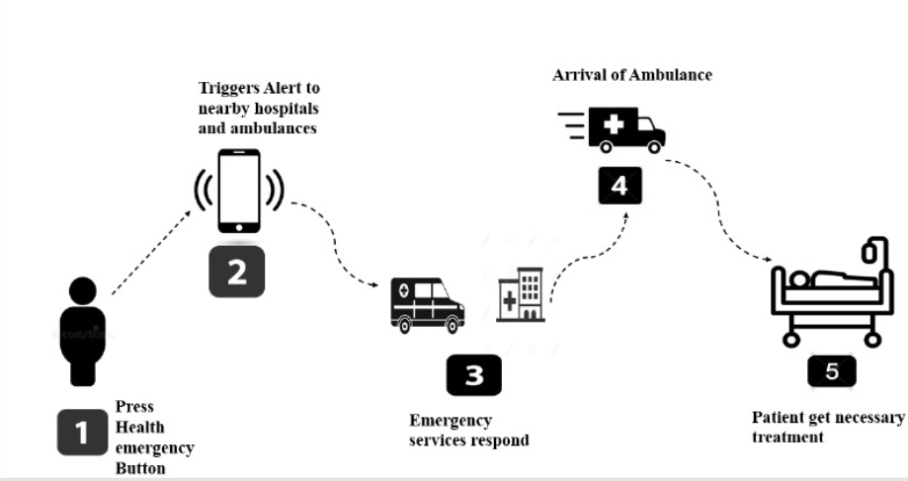

**Use case Phases**

**Phase 1: Health Emergency Detection**

Ms. Priya experiences severe chest pain at home and, feeling panicked quickly opens the emergency app and presses the emergency button.

**Phase 2: Location Pinpointing and Alert Broadcasting**

The app instantly locates Priya and triggers an emergency alert to nearby hospitals and ambulances.

**Phase 3: Response from Ambulance and Hospital**

A nearby ambulance and hospital were detected. The app optimizes the ambulance route for the fastest arrival while confirming hospital readiness and E2E QoS ensures priority for all emergency-related traffic.

**Phase 4: Continuous Communication and Real-Time Updates**

The app tracks the ambulance progress and continuously updates Priya’s health status to the hospital and E2E QoS ensures uninterrupted communication.

**Phase 5: Timely Arrival and Treatment**

The ambulance arrives quickly, and Priya receives immediate medical care at the hospital.

**Phase 6: Emergency Resolution and Network Resource Reallocation**

Once the situation is resolved, E2E QoS management restores normal network resources, reallocating priority back to regular users.

## Use case requirements

**Requirement-1:**

It is critical to have real-time location tracking, health data transmission and anomaly detection with E2E QoS low-latency emergency services.

**Requirement-2:**

It is critical to have AI/ML algorithms for route optimization are deployed to identify the fastest route for ambulances in real-time, taking into account traffic conditions.

**Requirement-3:**

It is critical that E2E QoS management policies must be established in the network to prioritize emergency traffic over regular data traffic, ensuring reliable communication.

**Requirement-4:**

It is critical that continuous monitoring of health data and location is conducted to provide hospitals with real-time updates until the patient arrives.

**Requirement-5:**

It is critical that E2E QoS triggers normalization and reallocation of network resources back to regular priority users once the emergency is resolved

## PS1: pipeline design

* **AI/ML Concept Used** is Real-time data analysis, route optimization, and anomaly detection.
* **Relation with ITU Y.3172**: AI-enabled network resource management for emergency services.

**Requirements for This Type of Application:**

* **SRC of Data**: Location
* **Collector**: Edge servers.
* **Models**: Route optimization and anomaly detection.
* **Policies**: Policies to prioritize emergency signals based on the user’s status and location.
* **Distributors**: Edge server for distributing data to hospitals and ambulances.
* **Model Inference Application (SINK)**: xApp for managing network resources and prioritizing traffic.

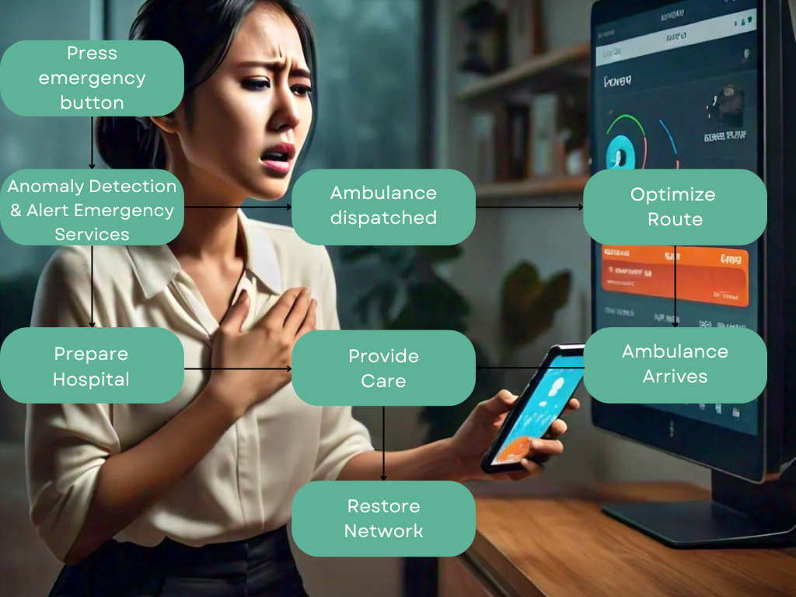

Source: Image Background- meta.ai

## PS2: xApp design:

* ORAN concept used is E2E QoS Management.
* In our use case 5G/6G Sandbox is used to validate low latency communication, Test AI/ML Models for Real-time decision-making, and ensure effective emergency traffic polarization.

Code: TBD

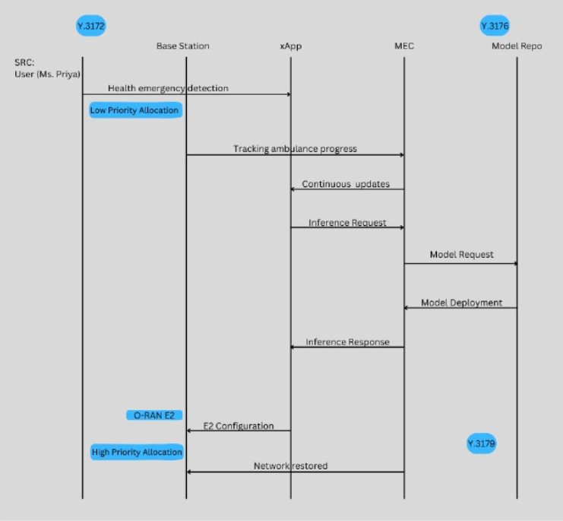

## Code submission details:

1. Created a GitHub account.
2. Created a GitHub repository
3. Uploaded use case document into the repository

This is our GitHub link:

https://github.com/rs5434/OMACS_use_case.git

## Self-Testing results:

TBD

_______________